2015
OSSGA INDUSTRY RECOGNITION AND STUDENT DESIGN AWARDS


Taking Stock of Our Industry

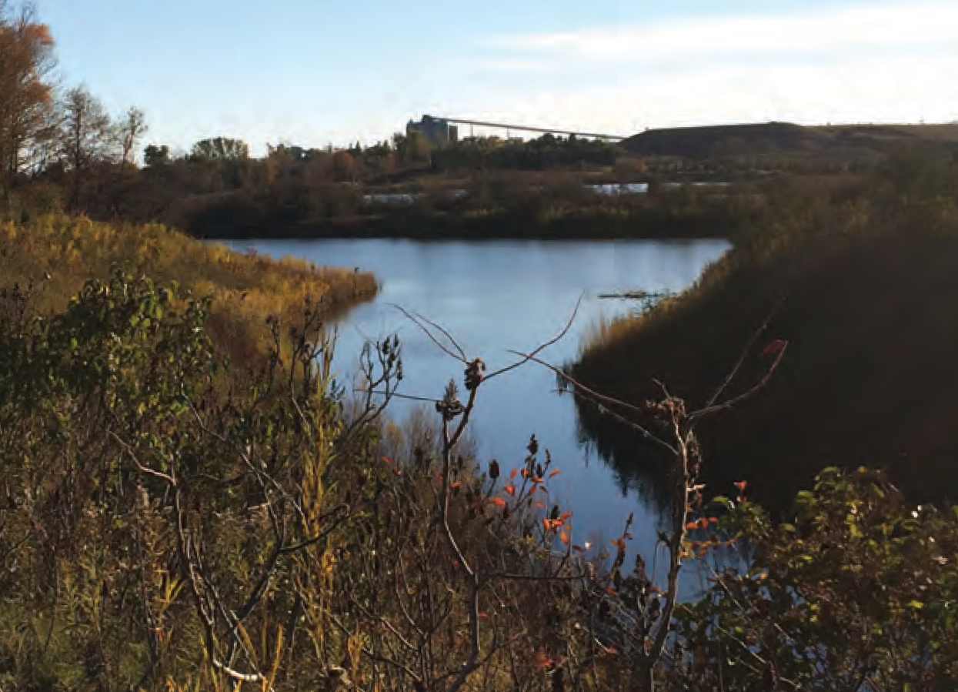
St Marys Cement –
A Division of Votorantim Cimentos

Bowmanville Quarry Westside Marsh Municipality of Clarington
St Marys Cement Inc. has maintained an aggregate extraction licence for a 225-hectare quarry site near Bowmanville since 1963. As part of the planned quarry development, a 40.3-hectare wetland was to be removed and the resources beneath it extracted. Although the extraction permit predated almost all current environmental legislation, in 1995 St Marys invited the Waterfront Regeneration Trust to consult with the stakeholders and help develop a new site plan to protect as much of the marsh as possible, and to relocate the creek and marsh in an ecologically responsible manner.
The construction of the creek and marsh reconfigurations began in late 2002. In 2006, monitoring began to investigate trends in the biological and physical productivity of each habitat type that has been constructed, enhanced or


BIODIVERSITY
The Biodiversity Award honours OSSGA members for their contribution to sustaining biodiversity through species protection, habitat improvement and sustainable land use activities. They are also recognized for conserving biodiversity in a way that goes well beyond regulatory standard practices and typical activities undertaken by the industry.
Ontario’s Biodiversity Strategy, 2011 was central to the development of the award criteria. Each eligible project must demonstrate support for one or more of the following strategic directions: engaging people, reducing threats, enhancing resilience, and improving knowledge.
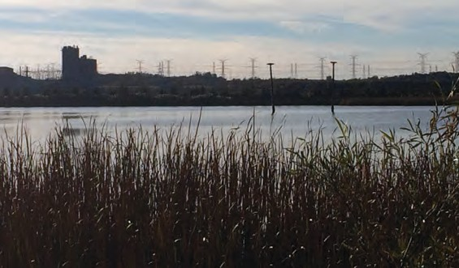

A SPECIAL THANKS TO THE JUDGES

The Biodiversity Award review panel included Steve Hounsell, Chair of the Ontario Biodiversity Council, Lynette Mader, Manager of Provincial Operations - Ontario for Ducks Unlimited Canada, and Ronald Reid, Carden Coordinator at the Couchiching Conservancy.
The Industry Awards review panel was comprised of judges invited from outside the industry, including Lynette Mader of Ducks Unlimited Canada, Nic Schulz of the Cornerstone Standards Council, Seana Richardson, MNRF Aggregate Technical Specialist, and Kristy Sutherland, MNRF Aggregate Technical Specialist. They were supported by OSSGA member Kevin Fitzpatrick of WSP Canada Inc. and Danielle Solondz of The Ontario Aggregate Resources Corporation (TOARC).
The Student Design Award review panel was comprised of members of OSSGA’s Rehabilitation and Species at Risk committees George Antoniuk of the Miller Group, Kevin Fitzpatrick of WSP Canada Inc., and Debra Kakaria, of MHBC Planning.
retained. Crews conducted water quality testing and took aerial photos to pinpoint changes in biodiversity, seeking out opportunities to improve shelter, feeding and reproduction. Other initiatives included relocating pest species, building habitat structures, adding special features to enhance resilience,
and introducing raptor poles to attract beneficial “tenants.” The site is now home to a large group of osprey that protect the marsh from unwanted birds.
St Marys has dedicated the land to the Central Lake Ontario Conservation Authority. To this day the company remains strongly committed to preserving the area’s unique wetland environment and, through a Community Relations Committee, ensures the ongoing health and wellbeing of the Westside Marsh. It also supports ongoing research and continues to monitor the wetlands and report on findings.


Supported by
COMMUNITY RELATIONS
The Community Relations Award recognizes those who have demonstrated leadership in promoting good neighbour relations, community involvement, education, and industry awareness.

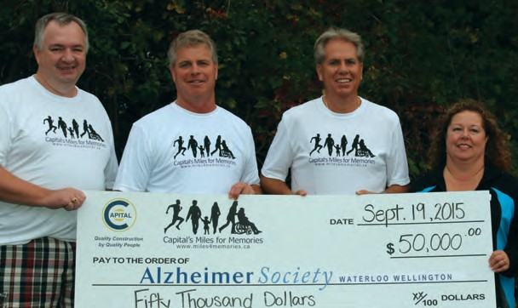
Capital Paving Inc.

Wellington Pit Township of Puslinch
Wellington Pit’s commitment to building community relations begins on its 100-acre site where a dust mitigation policy, noise control measures and safety initiatives keep the company in solid standing with neighbours. Constant communication through Capital Paving’s website and social media accounts, as well as comprehensive feedback
systems and one-on-one meetings, keep everyone informed. Wellington Pit and its Capital Paving parent company are just as active in the community. In addition to supporting the new Heavy Equipment Operator program with the Conestoga College Institute of Technology and Advanced Learning, they recently brought back their Miles for Memories walk/run event, raising $110,000 for Alzheimer’s research to date.

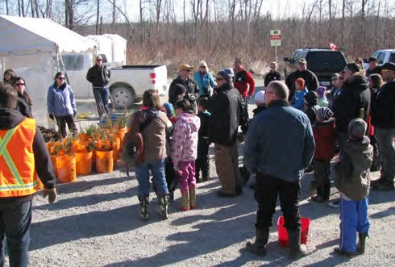
Dufferin Aggregates –
A Division of CRH Canada Group Inc.

Acton Quarry
Town of Halton Hills
Acton Quarry prioritizes community relations both inside its borders and beyond. Back-up beacons, rubber screening and noise barriers keep distur- bances at a minimum, while dust mitigation programs, proactive traffic measures and blast monitoring further ensure neighbours are unaffected by operations. Acton Quarry also plays a large role in its community, organizing a tree planting event with Scouts Canada, hosting an Annual Open House, and assisting the Darling Home for Kids with clean up. It regularly sponsors and donates monetary and in-kind donations to organizations and events, and its Community Advisory Panel (CAP) allows the local community to be involved in its operations.


Dufferin Aggregates –
A Division of CRH Canada Group Inc.

Milton Quarry Town of Milton
Dufferin Aggregates’ Milton Quarry leaves no stone unturned when it comes to neigh- bourly relations. The company demonstrates stewardship in water usage by working with stakeholders from the provincial government, the Niagara Escarpment Commis- sion, Halton Region, Conservation Halton and the Bruce Trail Conservancy. It holds onsite tours, an annual tree planting program and educational programs with local students. Staff volunteer at events like the Townline Road Clean Up and the Darling Home for Kids Clean Up. The quarry donates materials to local groups and contributes financially to sports teams, and Dufferin Aggregates coordinates the Ready-Mix Drum Sponsorship Program for Halton Healthcare Services, raising nearly $100,000 each year.

COMMUNITY RELATIONS

Lafarge Canada Inc. –
A Member of LafargeHolcim

Brechin Quarry Township of Ramara
At Lafarge Canada’s Brechin Quarry noise is minimized by berms and trees, as well as
rubber chute linings and rubber panels on the main scraping screen. Regular site sweeping and watering, as well as a high-pressure,
low-volume dust suppression system at its secondary plant, help control dust. Employee training and traffic enforcement ensure safety, and blast monitoring and constant

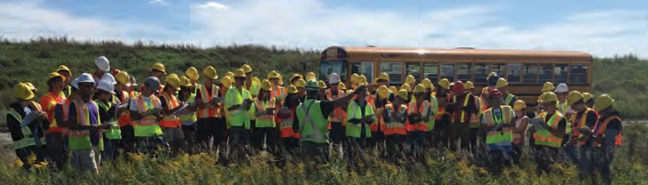
communications ensure residents are aware of quarry activities. Offsite, Brechin Quarry sponsors the Orillia Relay for Life, and takes part in the Orillia Santa Claus Parade. Lafarge

has also worked with the Ramara Community Police to introduce its cycling safety campaign. It provided resources to create the Brechin Public School outdoor classroom.

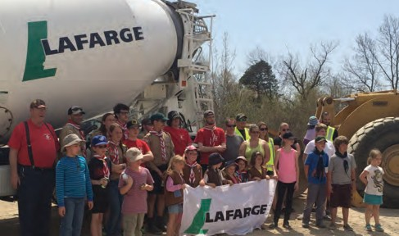
Lafarge Canada Inc. – A Member of LafargeHolcim

Hagersville Quarry Haldimand County
Staff at Lafarge Canada’s Hagersville Quarry volunteer to assemble beds for the Brantford Homeless Shelter, offer support for a local Christmas free skate event, plant trees with Boy Scouts and sponsor events like Youth Barrel Riding. At the Hagersville Quarry site, noise control, dust mitigation and blast monitoring minimize the impact of the operation on local residents. As well, Lafarge
and Hagersville Quarry demonstrate an unwavering commitment to safety, holding safety demonstrations and public awareness campaigns throughout the year. Site safety is prioritized with extensive driver training, regular vehicle maintenance and ample road signage.

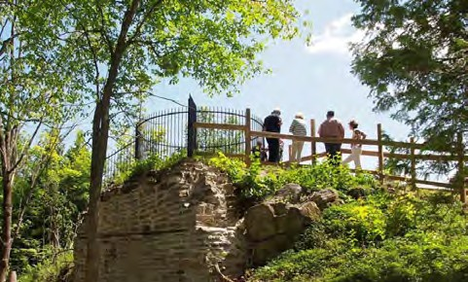
Walker Industries – Walker Aggregates Inc.

Duntroon Quarry Duntroon
The secret to Duntroon Quarry’s community relations’ success is its focus on treating neighbours like partners. The quarry’s Public Liaison Committee meets at least four times a year, and its Neighbourhood Picnic & Barbecue and Holiday Wine & Cheese Reception keep community members in constant contact.
Duntroon Quarry is a regular at local events, sponsors community clubs and sports teams, and donates resources and money to initiatives like the Bruce Trail Club. Onsite, water trucks mitigate dust, retired police officers monitor traffic speeds, and an environmental closure further reduces noise and dust. Quarry staff also maintain a blast monitoring system and publish a Stone Views newsletter.

Walker Industries – Walker Aggregates Inc.

McGregor Quarry Town of Amherstburg
Being a good neighbour is important for Walker Aggregates’ McGregor Quarry. Opera- tional disruptions are kept at a minimum through blast monitoring, complaint and feed- back systems, and vegetated berms and screens placed along the quarry’s road boundaries.
Dust is controlled with consistent watering, processing plant improvements and a dust management plan. Safety measures are also implemented, including visible rules and regu- lations signs, safety notifications, Walkers’ safe

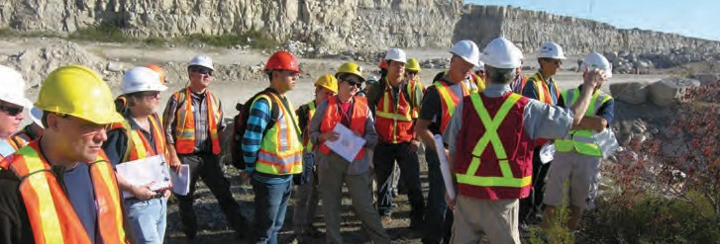
loading program and ongoing staff training. Offsite, Walker invests in its local community. It donates $5,000 to the Windsor-Essex food bank, sponsors the summer Ribfest, and hosts

a community barbecue. These and other outreach efforts are communicated via the company’s BorderStones semi-annual news- letter and the Walker Aggregates website.

COMMUNITY RELATIONS

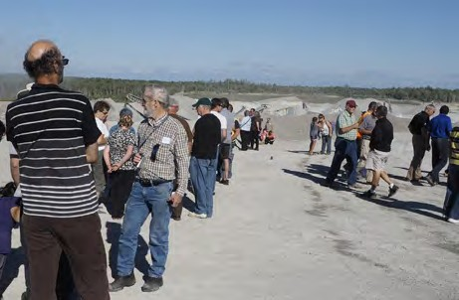
Walker Industries – Walker Aggregates Inc.

Severn Pines Quarry Township of Severn
Walker Aggregates’ community commitment is alive and well at Severn Pines Quarry. Year-round open houses, barbecues, and Public Liaison Committee meetings keep the quarry in touch with neighbours. Staff are familiar faces
in the Orillia/Stayner and Creemore Santa Claus Parades, and they help keep their community clean though garbage pick-ups and the local “adopt-a-road” program. Onsite, an upgraded water truck controls dust, while newly installed covers at the primary screens lower both noise and dust. A comprehensive blast monitoring system is in place and a retired police officer is employed to monitor the speed and noise of truck traffic. These initiatives are communi- cated at quarry events and through a Stepping Stones newsletter.

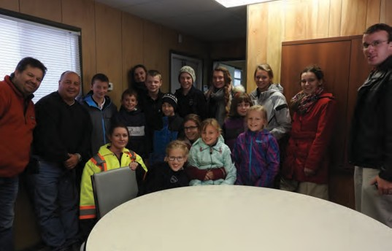
Walker Industries – Walker Aggregates Inc.

Vineland Quarries & Crushed Stone Town of Lincoln
Walker Aggregates’ Vineland Quarries & Crushed Stone recently went above and beyond its regular noise and dust mitigation practices by building an enclosure over its Megadome and installing misting fans and a Monsoon Air Mister to control dust. Vineland Quarries also invested in extra tarps for its stockpiles and a weather station to monitor wind speed and direction in order to notify staff of changes that could affect dust distribution. Employee and visitor safety is prioritized with extensive signage and safety awareness initiatives.
Vineland Quarries’ affinity for forging neighbour relations is evident in its many community outreach efforts. These include the company’s annual Earth Day Cleanup and its participation in the local Habitat for Humanity build.

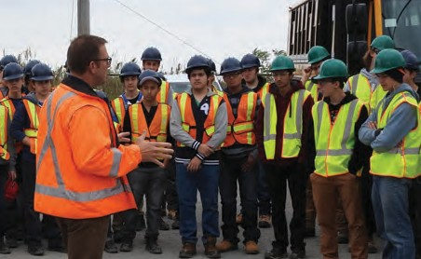
Walker Industries – Walker Aggregates Inc.

Walker Brothers Quarries
Town of Stamford (Niagara Falls)
Walker Brothers Quarries enjoys a sterling reputation within its community thanks to an ongoing focus on site improvements, operational excellence and commu- nity outreach. The site ensures its operations have little impact on those around them by controlling dust and noise with berms, water trucks and conveyer hoods. Additionally, it promotes site safety with rigorous traffic enforcement and signage. On the community front, the quarry hosts holiday parties, donates stone for local projects, works with students to raise industry awareness, and recently took part in Niagara’s first-ever Habitat for Humanity build. Updates on activities are conveyed through Walker Industries’ Walkways newsletter and its website.

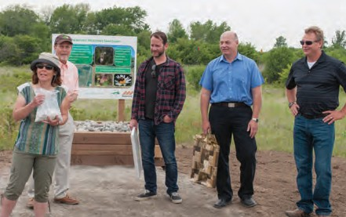
Waterford Sand & Gravel Ltd.

Vinemount Quarry Stoney Creek
Waterford Sand & Gravel makes neighbour relations a priority. Ongoing repairs to major roads have optimized site safety, while noise mitigation efforts minimize
disturbances. The quarry’s continuous watering and sweeping program helps lower dust emissions, and neighbours are kept abreast on operations and plans with
site tours, flyers and events. Vinemount Quarry recently donated material to the Hamilton Conservation Authority for local trail improvements, and paired with the Hamilton Naturalists Club to donate $20,000 in services and materials for the newly opened Vinemount Meadows Sanctuary. The 16-hectare area north of the quarry is now home to a large number of unique bird species.


PROGRESSIVE REHABILITATION
The Progressive Rehabilitation Award recognizes ongoing efforts of individual operators in progressively rehabilitating their sites in accordance with their site plans.

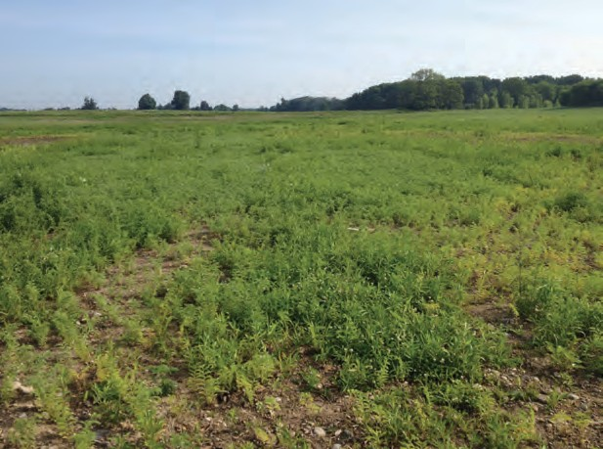
CBM Aggregates –
A Division of Votorantim Cimentos

McGuffin Pit
Municipality of Thames Centre
CBM Aggregates’ McGuffin Pit progressive rehabilitation project was established to create quality agricultural land following mining activities. The work, which took place from 2012 to 2015, required substantial contouring. In 2012 and 2013, overburden from local subdivision develop-
ments built on former agricultural lands was transported to the site, while overburden from onsite berms was used to create side slopes. Altogether 20,000 cubic metres of topsoil was applied at a depth of 30 centimetres. After the final contouring work in October 2014, a grass/legume mixture was seeded at 100 kg/ha to provide a cover crop. This was followed by further seeding of chickpeas in May 2015 to prepare the site for the first marketable crop of winter wheat that fall. Production at the site is expected to exceed initial expectations thanks to a higher-quality topsoil applied to a greater depth than originally planned.

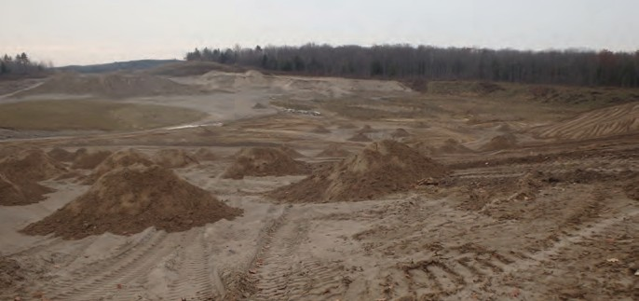CBM Aggregates – A Division of
Before
Votorantim Cimentos

Sunderland Pit Area 6 Township of Brock
CBM Aggregates’ Sunderland Pit rehabilitation project took place over the site’s Area 6 and covered 3.1 hectares of the pit’s extractable area – 256 hectares in total. The work took place from May to October 2014 following the completion of extraction operations in October the previous year. During this time, 8,000 cubic metres of overburden was taken from an onsite stockpile
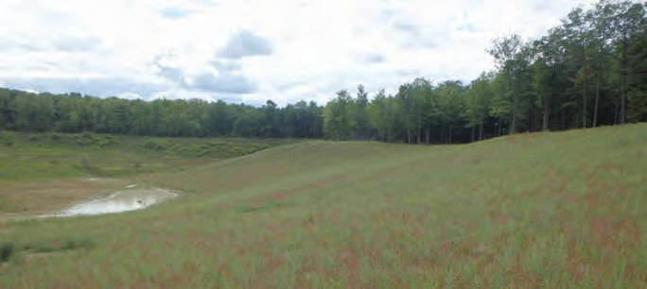to form a rough side slope with a 3:1 ratio, then 30 to 35 centimetres of topsoil was spread on the slope and pit floor. Finally, a seed mix of rye, buckwheat, alfalfa, crown vetch, clover and fescue was applied at a rate of 125 kg/ha. The equipment used for the progressive rehabilita- tion included Volvo 235 rock trucks, an 850C
After
John Deere excavator, a CAT D6 dozer for earth- moving provided by contractor Earthworks, and CBM’s ATV with seed spreader.

PROGRESSIVE REHABILITATION

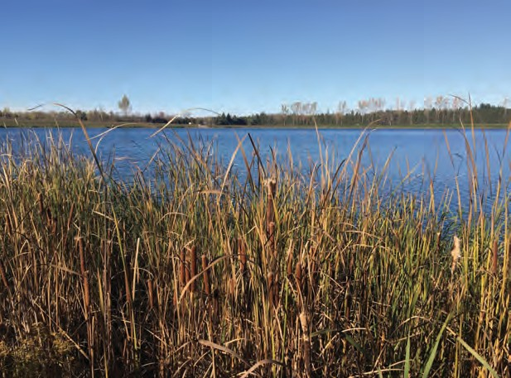
CBM Aggregates –
A Division of Votorantim Cimentos

Tikal Pit
Township of Puslinch
This progressive rehabilitation project returned 27.98 hectares of CBM Aggregate’s Tikal Pit to a natural state after extraction operations were completed in 2012.
It entailed the removal of perimeter berms, as well as shoreline contouring around the onsite pond and
application of 20 to 30 centimetres of stony topsoil and 40 centimetres of overburden. This was followed by seeding with a winter wheat mixture alongside various native forbs and grasses, including little bluestem, Indian grass, big bluestem, New England aster, heath aster, wild bergamot, black-eyed susan and evening primrose. An overseeding with a grass mixture occurred in spring 2015 to enhance grass coverage. Extra stumps, trees and oversized boulders from the original property were used to define the pond edge, while CBM partnered with the Grand River Conservation Authority to plant more than 12,000 trees.
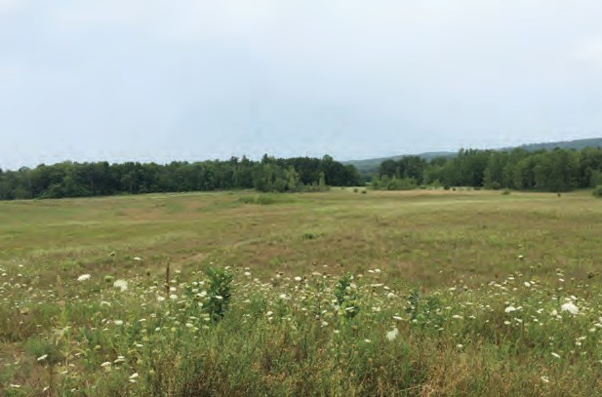
Judges’ Choice Award
CBM Aggregates –
A Division of Votorantim Cimentos
Whitehouse Pit Township of Brighton
The Whitehouse Pit’s central floor was targeted for this 2015 progressive rehabilitation project. The goal was to naturalize the depleted central portion of the pit so it could live on as open space. The work took place across 3.1 hect- ares of the pit’s 24.6 hectares of extractable area, between August 2014 and September 2015. A total of 4,000 cubic metres of overburden was moved from a nearby berm and spread over the pit floor. Once the overburden was in place, the last topsoil berm was moved and spread at a thickness of 30 centimetres. CBM crews used an ATV with spreader to seed the area with a rye and clover mix at 125 kg/ha. Other machinery used on the project included CBM’s 980G CAT Loader and a 690 John Deere Excavator and 450 John Deere Dozer, supplied by Indewey Excavating.

CBM Aggregates –
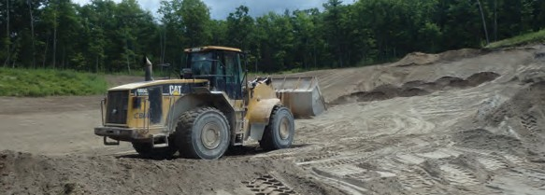A Division of Votorantim Cimentos
Before

Widdicks Pit Township of Brighton
Naturalization and reforestation were the end goals for Widdicks Pit’s southeast slope and floor progressive rehabilitation. Work took place over 1.8 hectares of the site, which altogether totals
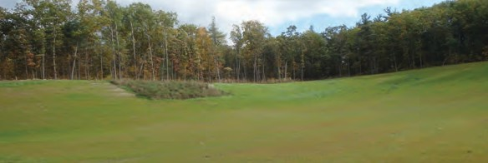8.93 hectares, with 5.50 hectares of extractable area. Work began in August 2014 with the movement of 6,000 cubic metres of over- burden to the site with CBM’s CAT 980 loader. The overburden was placed and graded to a 3:1 slope by Indewey Excavating’s John Deere dozer. Indewey also supplied an excavator to bail topsoil from nearby storage berms and deliver it to the top of the slope, where a dozer spread it to a thickness of 30 centimetres. In the fall of 2014 CBM used its ATV with a spreader to seed the area with a rye and clover mix at 125kg/ha. The following spring, employees returned to plant 2,500 trees throughout the area. This included a mix of red oak, sugar maple, white pine and white spruce.
After

PROGRESSIVE REHABILITATION

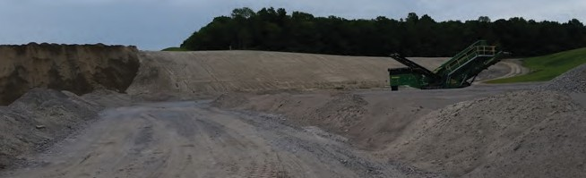Lafarge Canada Inc. –
Before
A Member of LafargeHolcim

Goodwood Pit Township of Uxbridge
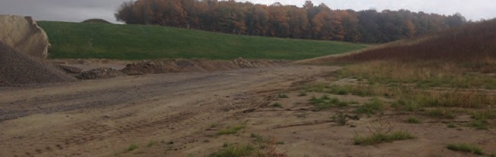In the summer of 2015, crews at Lafarge Canada’s Goodwood Pit continued their long-term progres- sive rehabilitation, moving closer to restoring the 109-hectare site for agricultural use and creating a lake. They were successful in rehabilitating 4.5 hect- ares of land using 80,000 cubic metres of material sourced from stripping operations. This included onsite topsoil, which was applied to the rehabili- tated area at a thickness of 15 centimetres. Contrac- tors were brought on board to complete sloping and apply a MOT Seed Mix Standard of Road
After
Seed Mix Type C at a rate of 125 kg/ha. The mix contained buckwheat, alfalfa, crown vetch, white clover, perennial rye and tall fescue.

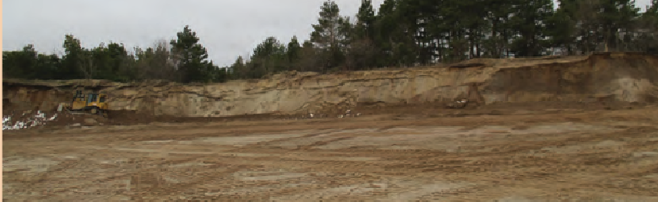Lafarge Canada Inc. –
Before
A Member of LafargeHolcim

Lawford Pit Town of Caledon
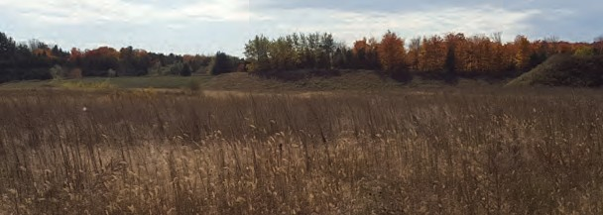The overall goal of Lafarge Canada’s Lawford Pit rehabilitation is to return 86.7 hectares of the pit area back to agricultural land while promoting the expansion of the Core Greenland forest and the Credit River. In April 2015 it took another step towards that goal by rehabilitating 1.42 hectares of land across two areas. Work began with the redistribution of overburden material to slope the exhausted faces at a 3:1 ratio, and then 20 centimetres of topsoil was applied. A red top Kentucky blue- grass Mix was then distributed, containing creeping red fescue, perennial ryegrass, Kentucky bluegrass and white clover for the purpose of protecting the area from erosion and preparing for re-vegetation. In total, more than 15,768 cubic metres of material was moved for the project using two 25-tonne articu- lated trucks, an excavator and a dozer.
After

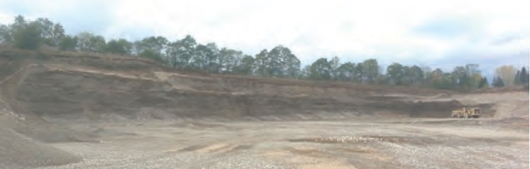Lafarge Canada Inc. –
Before
A Member of LafargeHolcim

West Paris Pit Township of Paris
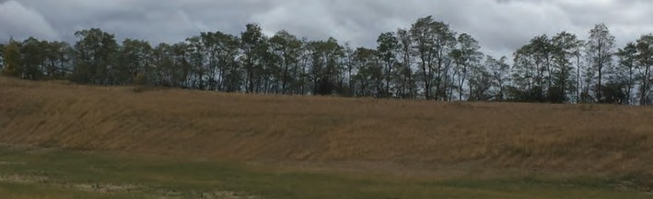Five hectares of Lafarge Canada’s West Paris Pit was the target area for this progressive rehabili- tation project conducted from August 2014 to July 2015. Approximately 20,000 cubic metres of material was moved, including topsoil applied at a 25-centimetre depth. A MTO Modified Lawn Mixture was later seeded to reduce gullying
After
and erosion. It contained creeping red fescue, perennial ryegrass, Kentucky bluegrass and white clover. The project used a D8 bulldozer, three haul trucks and an excavator. It was part of an overall progressive rehabilitation plan that will see 72.91 hectares of the pit made fit for short-term agricultural use, and, in the longer term, open and green areas for residential and recreational use.

PROGRESSIVE REHABILITATION

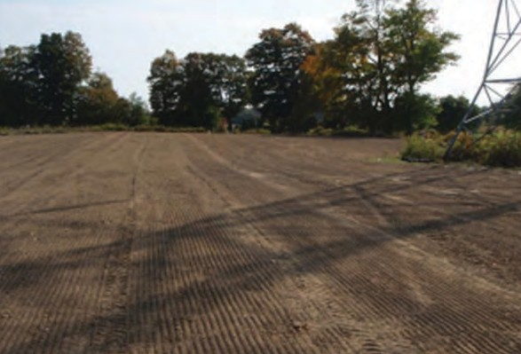
Lafarge Canada Inc. –
A Member of LafargeHolcim

Woods Pit
Municipality of Thames Centre
Lafarge Canada’s Wood Pit earned its first OSSGA Award for rehabilitating 7.5 hectares of the pit’s 34.46 hectares of extractable area. This parcel of land was chosen after an extensive evaluation showed that other areas of the pit were of poor quality and not worth disturbing. The project included sloping the pit face at a 3:1 ratio, adding 50 centimetres of subsoil and 20 centimetres of topsoil. A seed mix of creeping red fescue, perennial ryegrass, Kentucky bluegrass and white clover was then applied with a Brillion seeder at a rate of 155 kg/ha. In total,
10,000 cubic metres of material was relocated to attend to the slope and floor cover using a D6 dozer, excavator and rock trucks. The rehabilitated area was returned to agricul- tural use in keeping with the project’s objectives.

Walker Industries – Walker Aggregates Inc.

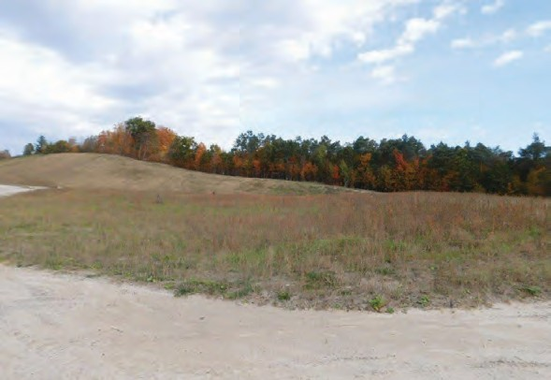
Anten Mills Pit
Township of Springwater
The goal of this 2015 initiative was to rehabilitate 2.3 hectares of Walker Aggregates’ Anten Mills Pit while protecting the endangered Eastern Whip-poor-will bird on the site. The work, conducted in June 2015, began with the transportation of
sub-material to the top of the boundary and the formation of a 3:1 slope. Topsoil was spread over an 8-to-13-centimetre cover to support seeding, which consisted of a mix of big bluestem, Canada wild rye, switch grass, little bluestem, Indian grass, timothy and annual rye grass. In the final stage, vegetation was removed from the original onsite area and moved to the newly
designated area. This included natural grasses, ferns and stumps. The rehabilitation was completed in keeping with the aim to protect the Eastern Whip-poor-will. Walker Aggregates will continue its ongoing rehabilitation efforts on the northwest side of the Anten Mills Pit in the spring.

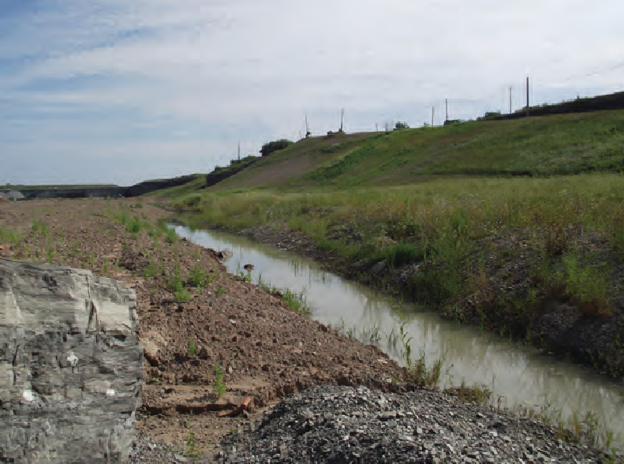
Waterford Sand & Gravel Ltd.

Vinemount Quarry Stoney Creek
Vinemount Quarry’s latest progressive rehabilitation effort saw crews restore three hectares of its 20.25- hectare extractable area for use as green space. The job required the transportation of approximately 150,000 cubic metres of overburden and topsoil to the site, with topsoil spread to thickness of 10 centimetres. Sidewalls were sloped to a 3:1 ratio. An MTO Roadside seeding mix was applied consisting of creeping red fescue, Kentucky bluegrass, perennial ryegrass and white clover. The ongoing rehabilitation includes the planting of pine and spruce trees along the berms between the quarry and neighbouring properties, as well as the planting of a wide variety of plants and shrubs.

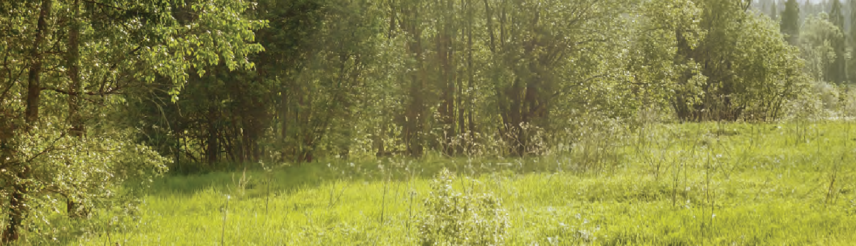
PROPERTY ENHANCEMENT
The Property Enhancement Award recognizes operational best practices in a site’s entrance, approach and perimeter screening, office and scale house areas, employee areas, plant appearance, environmental controls, truck and mobile equipment, and communicative signage. Sites that initially meet the minimum requirements in each of the aforementioned sections are awarded a plaque. Site operators are then provided with an opportunity to win a “gold” bar for each section by meeting the comprehensive list of criteria for each. There are a total of seven “gold” bars that can be achieved.

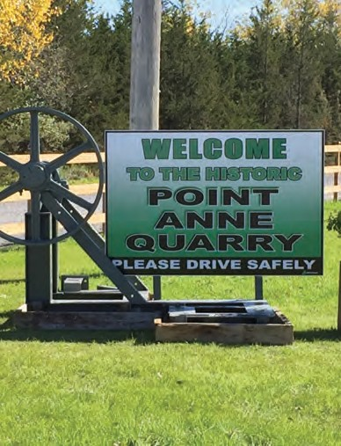
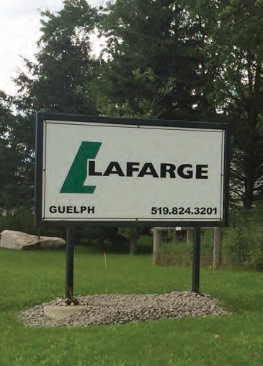
Lafarge Canada Inc.
Guelph Pit & Quarry, Guelph One Gold Bar: Communicative Signage

Lafarge Canada Inc.

Point Anne Quarry, Belleville
Two Gold Bars: Office & Scalehouse;
Entrance, Approach & Perimeter Screening

Miller Paving Limited
Carden Quarry, Brechin
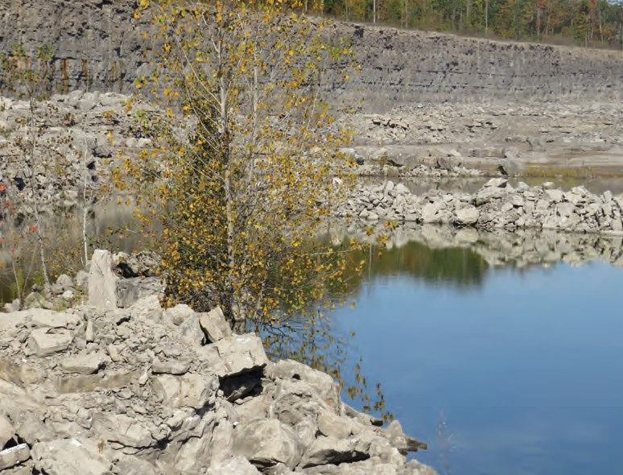Plaque and three Gold Bars: Office & Scalehouse; Entrance, Approach & Perimeter Screening; Communicative Signage
Nelson Aggregate’s Lincoln Quarry

Nelson Aggregate Co.
Lincoln Quarry, Beamsville
Four Gold Bars: Employee Areas; Trucks & Mobile Equipment; Plant Appearance; Environmental Controls

Nelson Aggregate Co.
Oneida Quarry, Haldimand County Plaque and One Gold Bar: Office & Scalehouse

Waynco Ltd.

Waynco Pit, Cambridge
Two Gold Bars: Environmental Controls; Trucks & Mobile Equipment

Supported by
STUDENT DESIGN COMPETITION

Generous funding for the competition was provided by The Ontario Aggregate Resources Corporation
The Student Design Competition recognizes the most innovative designs for the ecological revitalization of a former pit or quarry. This year, students were challenged to create site plans for Vicdom Sand & Gravel (Ontario) Limited’s Brock Road Pit, located in the Township of
Uxbridge in the Region of Durham.

1st Place ($3,000) – Stopover Ecology

Jaclyn Ryback, Karen Lui - University of Toronto
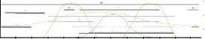
This 1st place submission sees the Brock Road Pit repurposed as a wildlife refuge and stopover site for migratory birds. The plan was inspired by the Nature Conservatory’s Great Lakes Migratory Bird Stop-

Quantity

stopover ecology | final rehabilitation

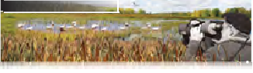
site activity calendar
Programmed site activities for visitors in relation to the annual influx of birds

Year-Round Species:

American Goldfinch House Sparrow Northern Cardinal
Black-capped Chickadee Northern Goshawk

P2

Photography Bird Counting Hiking
Cross-Country Skiing

Skating

Migratory/Stopover Species: Cabin Rentals
Bird Banding

over Study, which identified the location as one of a select few migratory resting places for waterfowl

January February March April May June July August September October November December
Canada Goose
Snow Goose
Northern Pintail
Green-winged Teal Northern Shoveler

Summer Breeding Species:
Great Blue Heron Bank Swallow Spotted Sandpiper Belted Kingfisher Marsh Wren
Nest Box Building
School Field Trips Day Camp
Cabin Rentals

north of the Greater Toronto Area (GTA). The proposal outlines the loss of bird and wildlife habitats within the Uxbridge region and the GTA, pointing to the need for more stopover sites to support birds along their journey.
proposed final rehabilitation N

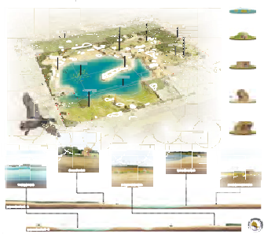
OObbservation Deckc

AA

340

LLake Resseeaarrcch SSttaattiioon

Inntterrpprreettiveve CeCennttrere

340340

340

330330

PitPit EnEnttrranccee/E/Exixitt

MMeaaddoow RReessearchrc SSttaattiioon
design components

Floating wetlands will be constructed on the lake, providing additional habitat and resting spots for waterfowl and other wildlife species on the open waters.

P2

330
Sandy Shore
330
Meadow

Observation
Deck
In-g-grouunnd
CCabbiinsns
B

340340
Meado
In-ground cabins provide visitors the
opportunity to stay overnight in nature.
Being fully integrated into a rolling meadow
landscape, visitors will be able to observe
wildlife without being noticed.

Stopover Ecology calls for turning the land into a “dynamic ecosystem” through regrading and re-vegeta-

330330

B

34340
Research Station 320 Sandy Shore

Floating Wetlands

Giordano Lake Water level: 315 m Lake Bottom: 286 m

Wetland Boardwalk Trail

330
ead w

340340

330330
330330

Pocket research stations are located throughout the site in each ecological typology serving as rest stops for visitors and research facilities for observational studies.

tion, and the gradual integration of vegetated building typologies. It suggests a number of onsite features
Wetland Research Station

Wetland

P1

to attract human visitors to the site and strengthen their connection to the natural world. These include the installation of an interpretive centre, in-ground cabins, floating wetlands, an observation deck, and multiple research stations, all connected via nature trails and a wetland boardwalk. To further encourage human interaction, the site would provide activities such as bird banding, bird counting, hiking, cross- country skiing, hiking and tours.

floating wetlands

proposed section A - A

proposed section B - B

320320

observation deck

320320

Wetland

A

rolling meadow cabins

330

wetland boardwalk

Observation decks provide ideal vantage points of the site for visitors. Given the height of the structures and their exposure to the elements, there is opportunity to use them for seed dispersal by natural means (wind and/or wildlife).

The interpretive centre is the main facility on site, offering visitor information, research/educational spaces, and classes. The structure itself is a large observation deck located on the northeast corner of the site and provides the highest vantage point and best view of the entire rehabilitated landscape.

meadow research station

UXBRIDGE EQUESTRIAN VILLAGE

FINAL REHABILITATION

2nd Place ($2,000) – Uxbridge Equestrian Village

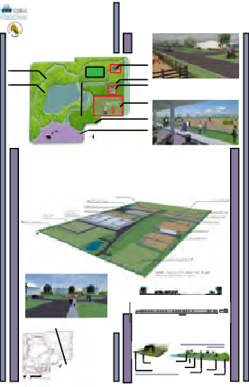Aisling Laverty, Ryan Chin - Fanshawe College

TRAIL SYSTEM PROVIDING HUMAN (AND EQUINE)USE FOR VEGETATION CORRDOR

VEGETATION CORRDOR (OAK SAVANNAH)

elevation groundwater table: 319m in the fall/winter 3
26m in the spring. no change in water courses

TREE NURSERY LOCATION

A’

LARGE ANIMAL HOSPITAL AND RESEARCH CENTRE

REPURPOSED HAUL ROADS
PHASE ONE

BOARDING BARN FACILITY
45 stalls ABOVE: The Large Animal Hospital and Research Centre showing the structure and surrounding fields.
2 oversized indoor and outdoor rings
PHASE THREE

BELOW: The proposed pavilion structure overlooking the competition ring.

SHOW FACILITY
5 competition rings
48 camper spots
627 stalls
This student submission outlines the development of a feature-rich equestrian community in the “heart of Ontario’s horse country.” The Uxbridge Equestrian Village would cater to horses and their owners, as well

A”

active extraction site 25 year life span starting in 2016
HORSE PASTURE AREA

HOUSING PHASE THREE: BASED UPON DEMAND OTHER- WISE, REHABILITATEDED TO VEGETATION CORRIDER

master plan
uxbridge equestrian village
1:4000
as animal and outdoor enthusiasts. It would incorporate a range of valuable resources, such as an Animal

Nestled in Ontario’s horse country, live the dream of having your horse in your backyard, access to a top notch facility with multiple, oversized indoor and outdoor riding rings without the responsibility and inconvenience of facility ownership, all while being only a short distance from several urban centers.
Welcome to the Uxbridge Equestrian Village. The village goes much further than simply living arrangements for yourself and your horse: featured on site in a state of the art Large Animal Hospital and Research Clinic run in conjunction with Durham College’s Veterinary Assistant Program. This clinic will offer students unique learning opportunities as well as quality routine and emergency care specifically for large animals. The site also features a horse show facility with five competition rings, stabling for over 600 horses, and 48 camper spots. Enjoy the use of the site’s new vegetation corridor with a horse friendly trail system connecting to the nearby Durham Regional Forest and existing trails in the area. Sip your coffee from you back porch while watching your horses graze in the morning before work. Experience the ease of horse ownership once your horse is mere minutes away. Connect to nature with the trail system. Have peace of mind for the health of your animal and be a short walk- and no trailer ride, to world class horse shows and veterinary care. Live in the Uxbridge Equestrian Village.
Hospital and Research Centre, stabling for 600 horses, 48 camper spots, oversized indoor and outdoor riding rings, a horse pasture and a network of horse-friendly trail systems.
The plan proposes a multi-stage development, beginning with an Animal Hospital run in collaboration with the Durham College’s Veterinary Assistant Program. Phase Two would see the construction of the site’s show

PHASE THREE
BELOW: The proposed residential development.

B’

FINAL ELEVATION OF THE REHABILITATED AREAS OF THE SITE AS ILLUSTRATED BY ONE METRE CONTOURS
NOTES:

- Contour and site information is based on 1993 Existing Features CAD drawing file and 2008 Contour and Drainage information shapefiles.
- Regan Area (southwest corner of site) is an active extraction site with a 25 year lifespan. As such, it has not been recontoured. The accessed documents did not show extraction faces therefore, the final
PHASE TWO

A’-A” post-rehabilitation residential area

B’-B” post-rehabilitation elevation

FUTURE GROWTH
vegetative components
uxbridge equestrian village
oak savannah

Proposed Deciduous Tree
facilities, including a starting area with stalls and wash racks, five competition rings, general and show parking, and a vendor area with additional parking. The final phase calls for residential development and the construc- tion of a pavilion viewing area overlooking the competition ring. Various coniferous and deciduous trees would be planted onsite, and a mulched trail system and horse pasture would also be created.

elevation is not applicable here.
- The pond is sized accordingly to the documents accessed.
B”
- Slopes are rehabilitated to 3:1 at minimum. Slopes can range anywhere from 3:1 and can be more
topsoil 6”

Horse Pasture Seed Mix future growth
topsoil 6”
mulched trail system

oak savannah seed mix
Proposed future growth

gradual. This is demonstrated in the contour plan.
horse pasture
Coniferous Tree existing durham
regional forest

3rd Place ($1,500) – Ecology On Track

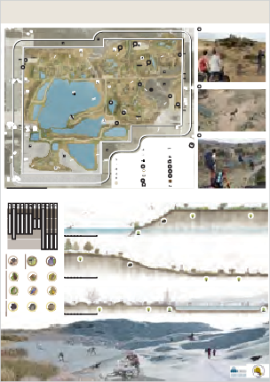
ECOLOGY-ON-TRACK: Final Rehabilitation

A DIRT JUMPING/ BMX BIKES

Anna Rosen, Hanna Chung - University of Toronto
Driven by a desire to develop cost-effective and sustainable ecology that promotes social interaction, this student proposal suggests transforming the pit into a motocross track. It reasons that a new motocross

C
B

P

P
A
  - E

B SAND BOARDING

!

D
  - F

park would provide riders with an alternative to the ecologically fragile forests and trails they currently
D

P

BROCK ROAD PIT3444 BROCK ROAD N LEGEND

C HIKING/ CAMPING

ride on. A regulated off-road park would also generate revenue both for the Town of Uxbridge and

Camping

Fishing

Beach/Swimming Watersports (canoe, kayak etc)
Site Entrance

Surface Water Drainage Key Natural Heritage Site Woodland

Picnicking

Biking/ Dirt Jumping
! Information/Facilities P Parking Lot

Vicdom Sand & Gravel.

Sandboarding
Site Boundary
Farmland

120m outside the site Buffers and Setbacks
Bird watching

Hiking/Crosscountry
Treatment Pond
Remaining Stockpiles

Scale 1:5000
0 50 100 500m
Skiing/Snowmobiling Wetland
Existing Structures

The track would be built primarily with onsite materials shaped into moguls, slopes and jumps for racing. This would create new opportunities for seed capture as well as water collection and channel-

RECREATIONAL ACTIVITY

RARE/ENDANGERED WILDLIFE

REPTILES BIRDS MAMMALS WINTER FALL SUMMER SPRING

CYCLING

BIRD WATCHING PICNICKING
BOATING
INSECTS
FISHING CAMPING
BEACH

SANDBOARDING

SNOWMOBILING SKATING
CROSS-COUNTRY SKIING

0 1 2 3 4 5 10m

HIKING

Scale: 1:100

SPRING/SUMMER Section DD

ling. It would promote vegetative growth and the creation of an eco-system to attract wildlife. Once

AMERICAN TWELVE-SPOTTED EASTERN

0 1 2 3 4 5 10m
Scale: 1:100

FALL

BADGER
SKIMMER
TAILED BLUE

Section EE

NORTHERN BEWICK'S WREN HENSLOW'S
BLUEBIRD MEADOWLARK

operations on the pit wind down, the motocross track could be relocated to areas surrounding the
BOBWHITE

SPARROW
CLAY-COLOURED EASTERN
SPARROW
SPARROW

EASTERN


gravel pits, keeping riders on regulated roads. The project would also clear the way for a host of addi- tional seasonal leisure activities on the site, such as camping, cycling, sandboarding, bird watching, cross-country skiing, snowmobiling, skating, fishing and swimming.

EASTERN MILKSNAKE EASTERN 0 1 2 3 4 5 10m
MASSASAUGA RIBBONSNAKE Scale: 1:100
RATTLESNAKE

3 of 3

WINTER Section FF

STUDENT DESIGN COMPETITION

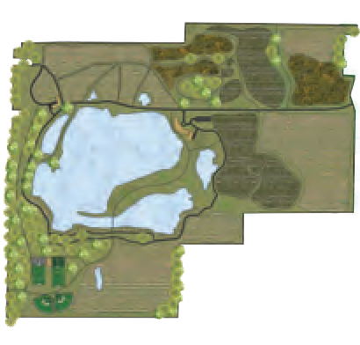W xan’s Grove
[ REHABILITATION
FINAL

DESIGN INFORMATION
Research Centre
The Agricultural Research Centre proposed is the inaugural

Trail System
The trail system at Wixan’s Grove will be developed using a very low-
achievement intended for the Wixan’s Grove redevelopment plan. A impact aggregate mixture produced on site. This will give the visitors partnership with Durham College’s Horticulture – Food and Farming pathways to explore and become entwined with the natural beauty of program will give the students a chance to be involved in researching the site. Areas of lower grades that risk ﬂooding or washing away will food crop growing conditions in their own backyard. In addition to be slightly raised by using a boardwalk style design. Additionally, a students, the centre will also house permanent researchers, who are pedestrian bridge will span a portion of the south side of the lake,

III

Honourable Mention ($750) – Wixan’s Grove

Andrew Sabourin, Mohammad Sefian, Wyatt Rotteau - Fanshawe College

DESIGN INTENT
intended to study ﬁelds such as crop hardiness, soil conditions,
transplanting and grafting.

Wixan’s Grove Estate and Cottages
creating a unique connection and lookout point across the lake.

Food Crop Production

Improved Wildlife Habitats
Many of South-Central Ontario’s native fauna call this gravel pit home, such as the Eastern Meadowlark, the Mallard and species of trout and

Wixan’s Grove proposes that the rehabilitation of the aggregate extraction sites at Vicdom Sand and Gravel be educationally, economically and environmentally viable in nature. The research facility, agricultural ﬁelds and estates proposed here will cater to both the human and ecological needs of the site.
From an educational standpoint, the research facility will house students and researchers from agricultural and
Although centred around wine and cider production, the estate is also of the site will be used as small service roads as crop production on bird and ﬁsh habitats, as well as the restoration of woodland areas and
horticultural backgrounds. This will ensure the crops and species planted on the site will be feasible and produce
the best possible product. The site is economically fueled by the inclusion of rentable estate properties and event
The estate and cottages at Wixan’s Grove are intended to be the main The production of grape and pear wine, ice wine as well as apple cider bass. The aggregate extraction has irreparably damaged habitats for economic driver for the property. By using cottage-style, non-intrusive will be the main oﬀerings of Wixan’s Grove’s food crop production, many wildlife, and although it cannot be replaced, it can be expanded architecture and building materials, the structures will be aesthetic and although as research continues, there may be room for diversiﬁcation and rehabilitated to encourage new habitats and new fauna to move
modern, but ﬁt into the existing cultural heritage of the region.
into the future. Many of the haul roads used in the aggregate extraction into the site. The rehabilitation of the lake and its bank will see new

intended to be used for large gatherings, corporate events, weddings these high-compact areas would be diﬃcult. The creation of the
the planting of new native trees. The intention of this rehabilitation is
and other private functions. Activities such as tennis, cricket and hiking saleable product itself will occur on site near the Estate for ease of use to see a new and abundant ecosystem form that is rich in biodiversity
The intent of this submission is to transform the site into “a premier destination for agricul-

space, guided tours, and eventually, the sale of wine and cider, all of which is grown and produced on site. Finally
and most importantly, the site is environmentally feasible because of its commitment to transplanting woodlands, rehabilitation and restoration of animal habitats as well as the re-introduction of native ﬂora and fauna. Additionally, the rehabilitation of the large, central lake will provide new and lasting beneﬁts for native species of ﬁsh, birds and other native animals.

Overall, Wixan’s Grove intends to serve as the premier destination for agriculturally-based tourism in the Uxbridge region and as an example of good rehabilitation projects for the Province of Ontario.

323

RESEARCH CENTER
2
A

GIORDANO LAKE

PEDESTRIAN BRIDGE
RENTABLE COTTAGES
3 321

WIXAN’S GROVE ESTATES
1
will also be available on site for visitors to enjoy.

LEGEND
for tours and visitors to sample the product.

WOODLAND

A’

316
PROPOSED CONTOURS (1m)

for both native animal and plant species.

WIXAN’S GROVE ESTATES
1

AGRICULTURAL RESEARCH CENTRE
2

WIXAN’S GROVE COTTAGES
turally-based tourism” within the Uxbridge region. The site would house a blend of vaca- tion-style amenities and agricultural land uses, appealing to the growing number of urban explorers seeking a break from big-city living.
Highlights would include the Wixan’s Grove Estate and Cottages, which could be rented for individual visitors, group events or corporate functions, and an Agricultural Research Centre, which would be run in partnership with Durham College’s Horticulture - Food and
3

ACTIVITY CENTRE
APPLE ORCHARD

VINEYARD PEAR ORCHARD
PROPOSED ROADS
PROPOSED TRAILS MAINTENANCE ROADS PROPOSED BUILDINGS
320
Farming program. There would also be an Activity Centre, a vineyard, a wide variety of food

GROUNDWATER TABLE ELEVATION IS BETWEEN 319.3 and 326m
0m 200 400

1:3500
crops and improved wildlife habitats.

BEYOND WIXAN’S GROVE
The concept of turning aggregate extraction properties into agricultural
AGRI-TOURISM
Wixan’s Grove intends to serve as an agri -tourism site, which will draw Why do people go to rural areas for vacation? Some examples given

RESEARCH

GIORDANO

APPLE
VINEYARD BROCK

food production and other agri-tourism sites doesn’t have to stop at Wixan’s Grove. If successful, the research and concepts demonstrated
in people from the surrounding heavily-populated Golden Horseshoe can include: a sense of adventure , heightened knowledge about Region. The mixture of agricultural land uses , including the grape, agricultural activities, improvements to health, to relax , and to escape
CENTRE
LAKE
ESTATE ORCHARD
ROAD

at Wixan’s Grove can be a template for further rehabilitation and
apple and pear production on site and the vacation -style amenities the everyday hustle of urban life. Whatever the reason, large
A A’

development of aggregate extraction sites throughout the province . Ontario has been historically rich with agricultural farm land and food production , many of which are under threat by rapidly expanding cities and towns . Loss of this industry could have serious economic impacts on the residents of rural areas. By heavily investing in the research and development of various crops and food products within newly rehabilitated extraction sites, a shrinking industry has the chance to be sustained.
provides the basis for this increasing popular niche.
The concept of agriculturally-based tourism is a fast-growing and ﬂourishing industry across Ontario. The Ontario Ministry of Agriculture, Food and Rural Aﬀairs encourages farmers and owners of agricultural production properties to seek agri-tourism options on their own properties. Their website states that the large populations of
urban centres often seek to escape to rural areas as these activities and experiences are not present in large cities.
population centres such as the Golden Horseshoe Region are teeming
with people who want a weekend to turn back the clock to a simpler
time where life doesn’t move so fast.

350
330
310

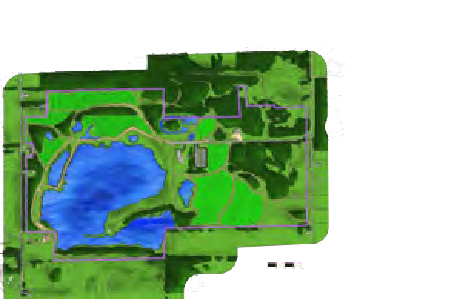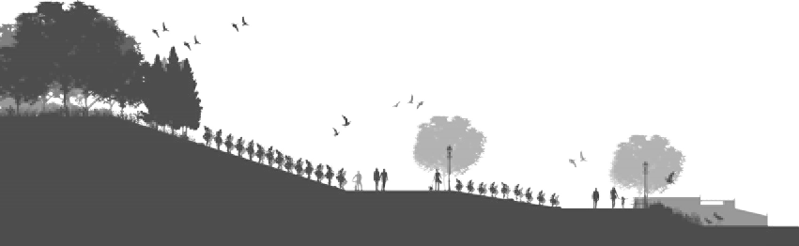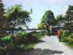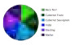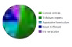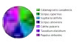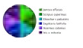Honourable Mention ($750) – Maggiore Lake Vineyards
Maggiore Lake Vineyards
final rehabilitation
Planting Map:
Pie charts representing plants and percentages to be grown in locations shown on map.
Wine Grape Types.
P1
Final Master Plan
Riparian Perspective
Fig. C3
P1
C1
P4
P2
P1
C7
Fig. C3 Photoshop render displaying the proposed, future rehabilitated ri- parian community along the lake (15+ years).
Moreover, this graphic illustrates the repurpos- ing of the roads to be used for winery equip-
Basic Rehabilitation Plants.
P2
C3
P4
C2
C5
Fig. C4 ment. Fig.C4 the before
P2
P4
photograph, and what is currently seen on site. (South Facing).
Winery Perspective
Fig. C5
P2
Riparian Plants.
P3
P3
P1
C6 P3
P1
Bioswale Plants.
P4
P3
P2
Scale - 1 : 5000
Lakeside Amphitheater
Fig. C6
Fig. C6. The lakeside amphitheater allows Maggiore Lake Vineyards to host small intimate concerts.
Fig. C5. Maggiore Lake Vineyards Winery. Implemented in year 15, the building will fea- ture large South-facing windows, full production and storage rooms, a wine shop, din- ing patio, and tasting room. To further promote our goal of sustainability the building will strive towards LEED certification. (East Facing).
Bioswale/Parking Lot Perspective
Fig. C7
Fig. C7 Perspective il- lustrates the complete vision of our proposed solution which is a suc- cessful progressive rehabilitation that con- tains the following major aspects: ecological en- hancement, biodiversity improvement, agriculture development, and inno- vative solution to com- pacted roads.
Thriving Ecological Corridor
Successful Vineyard
Compacted Areas
Section C1 - C2. East Facing. Approximately 15-20 Years.
Proposed Vineyard
Compacted Areas
Riparian Community
3

Adam Bedard, Davis Horrocks, Kyle David - Fanshawe College
Piggybacking on the growth of Ontario’s wine industry, this submission sees the creation of a multi-faceted vineyard and open-space venue delivering diverse services.
Maggiore Lake Vineyards would provide residents of nearby towns and cities with a break from urban chaos, while also generating revenue for Vicdom Sand & Gravel
during and following extraction activities. For visitors there would be different wines and refreshments on offer, as well as outdoor activities and lakeside entertainment.
The long-term plan envisions ecological and agricultural development on the site spanning many years, with a lakeside amphitheatre and other outdoor installations rounding out the vision.

Honourable Mention ($750) – Poplar Village

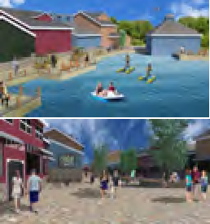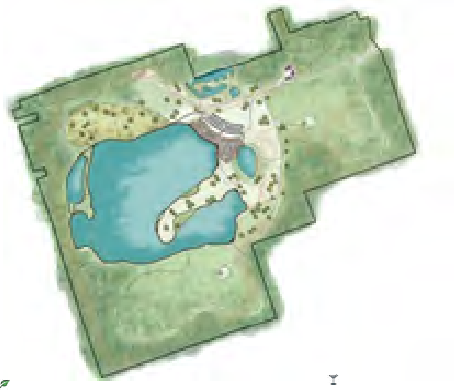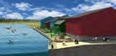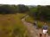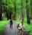Daniel Murphy, Matthew McHenry, Stephanie Chalmers - Fanshawe College
CONCEPTUAL MASTER PLAN
VILLA II
The second villa constructed, will also be the largest. With an unparalleled view of the Main Pond and the Village, Villa II will house the greatest amount of
people of all the villas within Poplar Village.
TALL GRASS PRARIE
The tall grass prairie habitat will allow visitors to gain further
education about habitat diversity. Multiple trails will intertwine through this incredible ecosystem.
EDUCATION &
RESEARCH CENTRE
Located on the trail system and near Poplar Road, the converted Vicdom Office and Maintenance Facilities will serve as an educational centre for all visitors. The Centre will also work on the monitoring of the natural systems within the village.

VILLA I
The first of the Villas that are available at Poplar
Mission

The task at hand is to successfully rehabilitate an aggregate pit through sustainable measures and create an economically viable alternative, that respects regional needs and context.

Vision

With the primary focus on the reintegration and
Village. In a wooded setting, the Villa is within
walking distance of the Village and its shopping
and dining experiences. THE development will provide users with a dynamic,
establishment of a rich natural system, Poplar Village, a sustainable, economically driven
VILLAS
There are to be three Villa type structures to be placed
THE TRAIL SYSTEM throughout the site, each with its own architectural style and
educational and exciting experience.

Values

Promote NATURE
unique landscape. Villa I is situated within a mature forest,
Poplar Village features an extensive trail Villa II is located among tall grass prairie and Villa III is located Be PROGRESSIVE
network that flows throughout the site. With on rocky plane, the site of former aggregate extraction. Each Create Economic OPPORTUNITIES
connections to the surrounding forests, Secord, will have its own unique feel and experience. Generate an EXPERIENCE
North Walker Woods and Clubbine, the trails
create a network that links Poplar Village to the The Villas are to be rented out by larger groups, and offer a surrounding area. longer stay at Poplar Village, and are to made available for
year-round use.
Foster SUSTAINABILITY
A C
B
POPLAR VILLAGE
At the centre of the entire development is Poplar Village. A dynamic destination with all the amenities one could ask for. Shopping, dining, nightlife and family fun can all be found within the Village, with connections to the surrounding grounds through trails and the main road.

THE EAST POND
One of the most exciting places to be within the Village is the East Pond. With dining and shopping experiences overlooking the pond and the opportunity to get a closer look on paddle boats and kayaks, The East Pond is the place to be.
THE MAIN POND BOARDWALK A
Additional Trail-side Parking
THE BOARDWALK
The Boardwalk allows users to fully appreciate the natural aspect of Poplar Village. Allowing visitors to get up and close with the water as interpretive signage tells a story of the rich history of the site as well as its rehabilitation into what will be seen as a precedent for aggregate rehabilitation.
REHABILITATED WETLAND
The West Pond will become an example of successful

former aggregate pit. Through interpretive signage, visitors will be taken through the process of implementing the wetland vision.
VILLA III
The final villa to be completed will be the most isolated from the rest of the site. Placed within the newly rehabilitated Regan Pit, patrons
will truly get a sense as to what aggregate pit
wetland rehabilitation on a
1:5000 Throughout the years, a woodlot will grow around
Grading: 1 Metre Contour Lines the villa, with further connections through the trail
rehabilitation looks like throughout the process.
Direction of Drainage
systems and the main road.
ENVIRONMENTAL
Several environmentally-guided initiatives will be established in order to fully integrate the site into the existing Durham Regional Forest. This will be done through various acts of rehabilitation and the
implementation of diverse habitats throughout the site including Tall Grass Prairie, Wetland and Woodlots. The establishment of a Green Corridor will create a wooded passageway to encourage an ecological weaving that was originally blocked by a right of way and aggregate operations. By creating a number of different habitats, the site can flourish in its rediscovered biodiversity. The main beneficiary of these environments would be the bird population, as the plantings of the rehabilitation project will immediately provide habitat for several of the area’s endangered and threatened species.
THE VILLAGE EXPERIENCE
Poplar Village has many things to offer in terms of Entertainment and Recreation both within the Village and the rest of the grounds. The Village will offer such amenities as; • Dining
- Spa
- Boardwalk
DEVELOPMENT
The development within the site will be concentrated within a Village-type setting. Clusters of two to three story structures will house shops, restaurants on the first floor, and rental units and hotel space above. These structures will have low environmental impact, using primarily recycled or on-site materials. Other evironmental features such as green rooves, permeable paving and solar panels will also be implemented.
Aside from the central village, other development will include three Villa type structures that can be rented out to large parties of people. These villas will offer three very unique areas to stay in; Tall Grass Prairie, Woodlot and a rocky slope.
- Shopping • Paddle Boating
- Farmers Market • Bars
- Entertainment Venues • Nightlife
- Hotel or Time Share • Art Galleries
- Convention Centre

Poplar Village and the amenities within will create a dynamic and exciting space, making it a Destination for the millions of people within the Greater Toronto Area. Poplar Village strives to be the piece of urban within the rural landscape.
THE EAST POND EXPERIENCE B
EDUCATION & RECREATION
Education begins with the alteration of the current aggregation operation office to an Educational Facility. Located on the main road and connected to the trails, this central building will offer many unique educational opportunities pertaining to aggregate rehabilitation, sustainability, and the further protection of the natural systems within the region.
A low impact Boardwalk feature will be placed around the central pond, creating unparalleled views and vistas for users who are looking to gain a closer look at the natural world created within Poplar Village.
Trail systems will intertwine throughout the site, creating a truly interactive and accessible experience for all visitors. The trails will connect users to all aspects within Poplar Village and its grounds as well as the surrounding managed forests.
POPLAR LANE C

LOT 10, 11, 12, 13

CONCESSION IV

TOWNSHIP OF UXBRIDGE

REGIONAL MUNICIPALITY OF DURHAM
POPLAR VILLAGE
A Natural Transformation Plan
This student proposal envisions a rehabilitated green space with a low-impact Poplar Village at its core. Designed with a focus on wildlife preservation, ecological enhance- ment and environmental awareness, Poplar Village would offer city dwellers an escape where they can shop, eat and be entertained while reconnecting with nature and the Durham Regional Forest. In addition to villas and hotel spaces to rent, there will be entertainment venues, restaurants, event spaces, nightlife attractions and unique retail experiences. Visitors can get close to the great outdoors and experience outdoor activi- ties like hiking, cross-country skiing and cycling. The Vicdom Office and Maintenance Facilities would be converted into an Education & Research Centre.

Honourable Mention ($750) – Ichthyo Rehabilitation

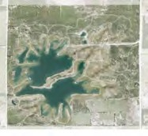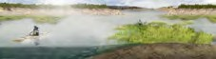Jasper Flores, Nathanael Wilner - University of Toronto
FINAL
01RE|HA0B2ILIT|AT0IO3N
PATH
+
FOREST
Dace
FOREST
A
A
+
SWALE
VISITOR’S DOCK
RIPARIAN / WETLAND
Darter
FOREST
PRAIRIE GRASS MEADOW
+
SWALE

Sculpin
VISITOR CENTRE/ WATER TRANSFER FACILITY
RIPARIAN / WETLAND
Brook Trout
0 50 100 500m
AFTER EXTRACTION
Replacing the pit’s aggregate extraction activities with ecological extraction is the goal of this submission. Ichthyo Rehab would transform the site and its natural resources into a rich source of native fish and plant stocks vital to the Duffins Creek Watershed.
There would be riparian and aquatic habitats, wetlands, a visitor centre and water transfer facility, a visitor dock, trails, and ample forest, swales and green spaces. The plan calls for augmenting the onsite lake in order to create zones with different water depths suitable for hosting diverse species of plants and fish. Ichthyo Rehab aims to nurture the full potential of this strategically situated pocket of land.

